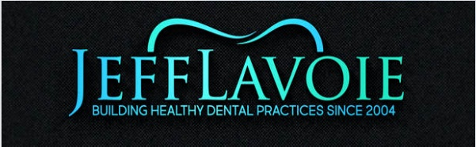
INNOVATIVE NEW PRODUCT
Monet the 1 Second Laser Curing Light

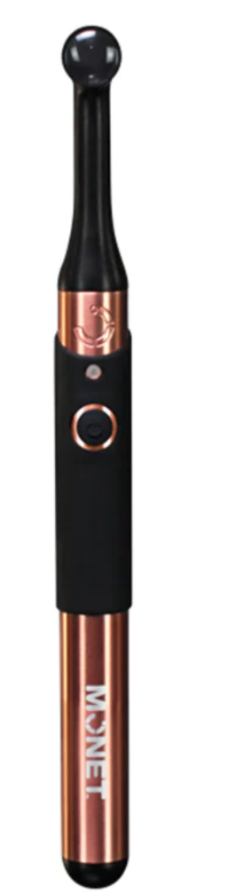
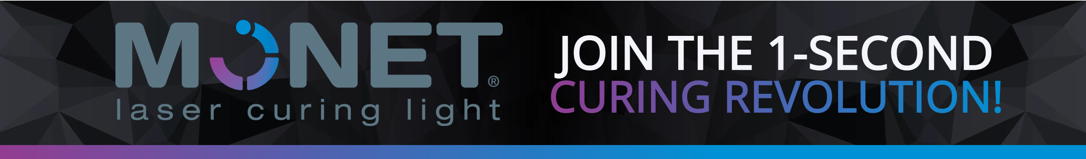Innovative Technology for Innovative Dentistry
The fastest dental curing light in the industry today, the handheld Monet curing laser is convenient and easy to use. The power of the Monet laser makes for superior bond strength and deeper, faster, and more consistent curing results from virtually any distance—in only 1 second.

Features:
- 1 second curing time
- Minimizes shrinkages and debonding
- Cures composites, luting cements, adhesives, and sealants
- 8mm curing depth capacity
- Consistent dispersion for a deep cure
- Reduces potential for “soft bottoms”

Included with Purchase:
- Compact laser module to fit the form-factor
- Optics for parallel beam within the form factor
- Unrestricted rotatable head mechanism
- Convenient battery attachment mechanism
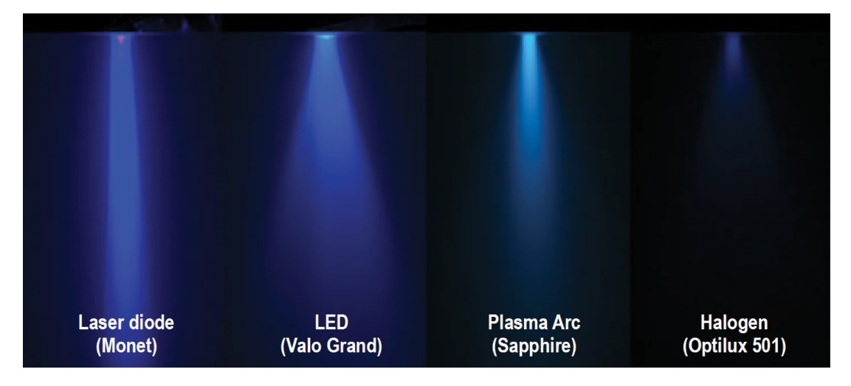
- * 2-Year Warranty

Jeff LaVoie | Territory Sales Manager
Building Healthy Practices Since 2004
Cell 781.789.5928 I Branch 978.262.5100 | Fax 978.262.5110
WWW.JEFFLAVOIE.COM

